Events
Author: Jan-Joost van Zon
Location: Oosterhout, The Netherlands
Date: October 15, 2007 - October 15, 2007
Copyright: Jan-Joost van Zon

Events can be automatically generated by J Data, but can also be freely added and raised. I will mostly talk about the generated events, here, though.

In J Data, events can be raised when changing an attribute value, when changing an object reference or when adding or removing an item from a list. Furthermore, there are the interaction events, but those are covered in the Interaction Events section. I may also add InitializeItem and TerminateItem events. But those will all use the same principle.

So in an Item Class, an event is raised in the Property Set procedures of attributes and related items. Those are called the Changed events. In a List Class, an event is raised when adding or removing an item, called the Added event and the Removed event.

However, this only allows the events to be picked up by a direct referrer of the object. If the event casting object is a grandchild, the events couldn’t be picked up by the grandparent. J Data has a solution for this and is able to channel the events of a sub-object upwards. I will just use a notation like:

SubObject_SubSubObject_EventName()

I will just use the VB event notation in a recursive way, where underscore separated elements can just stack up.

Ofcouse, in a system that can easily form circularities, the number of events would easily become infinite. Events by default go one level deep. You can also choose for a relation class or a class to cast all events x levels deep, and J Data will take care of that, but the most controlled way to case deeper events, is by specifying which deeper relation classes’ events will be casted upward in the CustomizedRelationClasses collections. For more information on those, see the Customization of Deeper Objects section.

Visual Basic 6.0 nor Visual C++ 6.0 support multicast event procedures by default, so I need to create a good multicast events scheme myself.

You can also specify custom events using a J Code structure to structuredly specify the event. These events can be used in the rest of the event scheme as described above. You can also specify custom events using mere string specifications, which can also be used in the rest of the event scheme.

Eventually events can also be specified in the class (or relation class) itself, not just in the structured custom code. In that case, things can be done in the user interface for it, so that you can see what events are raised when.

I used to have a good idea about how things should respond to eachother in an event driven system. However, it requires a good multicast event system. It also requires you to be able to pick up events from deeper objects. It also required a lot of event declarations and implementations and raising, which is no fun to program, but Creator can do that automatically.
I should think about how to create a perfect event driven system again. It will solve a lot of tricks I used to have to pull.

Ideas

Events,
2004

Another thing interesting in these kinds of objects is Changed events. Perhaps this must become something standard too.

In classes I always want changed events for the sub objects. The only reason I don’t add them for all sub objects is that it’s more code writing and Visual Basic may make the program heavier. Symbol however, doesn’t put anything unused in the compiled code. Oh, @#$, it does when a type with a load of changed events is a public member of the module. Hmmm… perhaps changed events must become a standard thing. That way you can really respond to any change without having to

JJ

Events
For practical reasons, a procedure that functions as an event procedure should only be an event procedure and not called by other procedures other than the event raiser.

I actually have not yet made many events about system activity with a start point and end point. I've merely used data events and interaction events.

I may create a property containing the status of an activity and create a data changed event and maybe a seperate
data event for each possible value the property gets. That gives us the system activity events.

Sets of events in com are actually methods of interfaces that a parent supports for the child to be called… Hmmm

< I might do it with events informing clients of data changes, and being able to reject a change. A locking scheme sort of counts on the same data not being accessed by multiple clients at once that much. So you might think, that casting an event will not never require so many clients to be informed. However, I’m dealing with objects here, the same data may have a lot of client objects, that get the event cast, even though no actualy user is accessing the object in any way at that time. >

<>
In Events it must be considered how applicable
this will be in Internet As A single Computer.

Applying a purely events driven scheme,
which ventilates changes to everywhere,
instead of applying something's state to
another thing once, actively letting things
adapt itself to a change of state, can
make the way a system behaves quite more
intuitive and organic and less rigid.

But I need to consider how much network traffic
this will cause in Internet as a single computer.

<>

Events, Casts
2008-06-23

Een cast is ook een concept: iets dat breed uitwaaiert, om iets door te geven aan mogelijk heel veel afhankelijke objecten.
Misschien is dit wel hetzelfde onderwerp als events.

JJ

Events,

(put this in the events article, because I’m not sure it will belong to the apply article, and I will probably do the event article first.)

Casting in, out and through properties of parameters might also be accomplished with an apply mechanism. You store whether a parameter of a command is in, out or thru, but if a (deep) dependency changes, an event is raised, that eventually reaches our command. This means, caching earlier output. Only when input changes, the change is passed on to dependencies and the chached output is dumped. I’m not sure, whether these were apply mechanisms, but I thought so.

JJ

From the original Symbol documentation

Events
<>
<< Is not a representation! Also: empty overridable members can also serve as events. But how would they have multiple sinks then? Would an event be a special representation of an overridable procedure and would putting them in a single interface be no more than putting all originally empty overridable procedures in a single interface? … heck, this is material >>

Events are a means for an object to call the container. The object defines an interface that the parent should support if it wants to receive the event calls of its child. The event interface parent has to make the interface implementation accessible by its child by setting an object sink of the child.

For this purpose you can choose to hide empty members of the implementation. You can also exclude any member of an event interface.

The problem with events was that there are two ways: overriding and assigning an event sink object that supports an interface that the event source defines.

From Another Place
There are techniques for a child to communicate with its parent. There are two similar ways: a child contains a reference to the parent’s procedure, a child contains a reference to the parent’s object. The child then has to define the interface of the object or procedure to reference. The child must also accept that the object reference might not point to an existing object. These techniques will be covered again lateron.

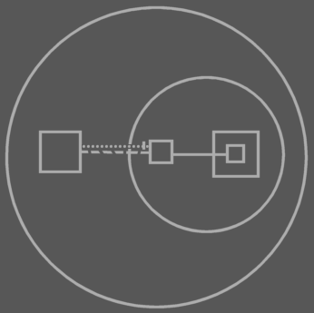  Reference to parent procedure with an interface defined by the child. | 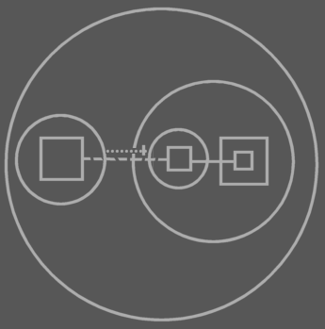  Calling procedures of a reference to a parent object with an interface that the child defines.
The dashed reference lines in these pictures could also have been notated solid.

Nog
Er is naast referentie naar procedure en referentie naar object nog een manier voor Events. Je moet namelijk ‘multi-cast’ events mogelijk maken en daar vereist een collection van event sinks die allemaal simulataan aangeroepen worden.. work it out

From the old symbol documentation
I need changed events to exist automatically

-----

Trouwens: Een multicast event is niet meer dan een object met een dimensie, die meerdere procedure references registreerd. Misschien moet er een speciale notatie zijn zodat je de lines ziet. Je moet van dat object met een dimensie een method aan kunnen roepen, die in een rij alle references aanroept. Daarom moet een dimensionaal object ook niet dimensionale members kunnen hebben, maar ik weet nog niet helemaal hoe dat dan gaat.

2004,

Giving properties instant changed events.

JJ

